26.14: a) The filaments must be connected such that the current can flow through each separately, and also through both in parallel, yielding three possible current flows. The parallel situation always has less resistance than any of the individual members, so it will give the highest power output of 180 W, while the other two must give power outputs of 60 W and
120 W.
Check for parallel: 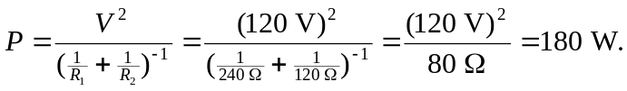
b) If  burns out, the 120 W setting stays the same, the 60 W setting does not work and the 180 W setting goes to 120 W: brightnesses of zero, medium and medium.
c) If  burns out, the 60 W setting stays the same, the 120 W setting does not work, and the 180 W setting is now 60 W: brightnesses of low, zero and low.

